**System Use Case Diagram Description**

*The use case diagram for the* ***Hotel-Reservations-Web*** *system (Figure 1) illustrates the main interactions between the user, the system, and external hotel data APIs.*

1. **Actors**

* **User**: Interacts with the system to register/login, search for hotels, view AI-recommended deals, and manage bookings.
* **System**: Handles user requests, communicates with APIs, applies AI logic to optimize results, and displays hotel data.
* **External Hotel API Providers**: Provide real-time hotel availability, pricing, and details (e.g., docs.hotelapi via etc.).

1. **Use Cases**
2. **Register/Login**:
   * The user securely creates an account or logs in to access personalized features.
3. **Search for Hotels**:
   * The user inputs search criteria such as destination, check-in/out dates,.
4. **AI Recommendation**:
   * The system uses AI to filter and suggest the best hotel options based on user input and preferences.
5. **Fetch API Data**:
   * The system retrieves real-time hotel information from third-party APIs, including room availability and pricing.
6. **Display Results**:
   * The system shows a list of hotels with key details (name, price, images, ratings, etc.) in a user-friendly layout.
7. **View Booking Details**:
   * The user can view detailed hotel information and booking options.
8. **Manage Profile**:
   * The user can update their personal data or view past searches and bookings.

Figure 1 shows how users interact with the system

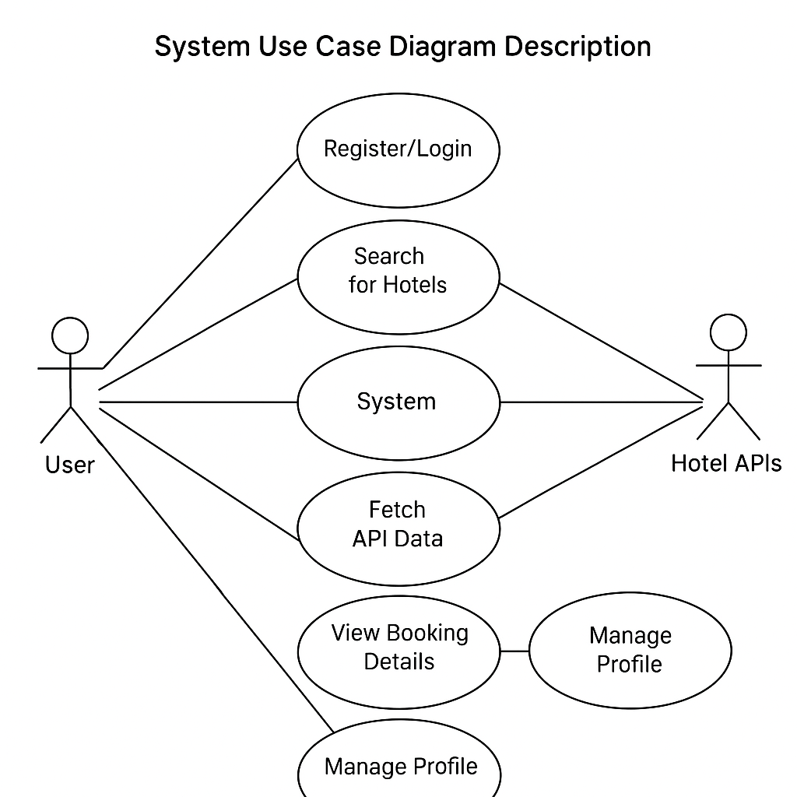

Figure 1: Use Case Diagram – Hotel Reservation System with User-Centric Features